* Module.1(fundamental)
* What is SDLC?

Software development life cycle is structure imposed the development software product that process for planning, testing,documentation,implementation, deployment and ongoing maintenance support.

* What is Software Testing ?

Software testing is a process to identity the correctness, completeness, quality of developed computer software.

* What is Agile methodology ?

Agile SDLC model is combination of iterative and incremental process model on process Adaptability and customer satisfaction by rapid delivery of working software product.

* Write SDLC phases with basic introduction ?
* Requirement Gathering : Features.

Usage scenarios.

Be incomplete, unambiguous, or even incorrect.

Requirement will change.

Functional and Non functional .

* Analysis phase : this analysis represents the “what” phase.

The requirement documentations to capture the customer’s perspective by defining goals.

This phase starts with the requirement document by delivered by the requirement phase , maps, architecture.

Design phase : Design architecture document. Implementation plan.

Critical priority analysis

Performance analysis

Test plan

* Implementation phase : critical error removal.

The implementation phase deals with issue of quality, performance baselines, libraries, and debugging.

A component may be narrowly designed particular system or made more general to satisfy a re-usability guideline.

* Testing phase : it is explain to a customer why there is a missing feature than to explain to a customer why the product lack quality.

Software maintenance is one of phase system development life cycle as it applies to software development maintenance phase deployment of software into the field.

Updating all analysis , design and user documentation.

* Maintenance : repair defects and adapt the solution to the new requirements.

Corrective maintenance: the identifying and repairing defects.

Adaptive maintenance: adapting the existing solution to the new platforms.

Perfective maintenance: implementing the new on decides value of software particular level of quality.

* EXPLAIN PHASES OF THE WATERFALL MODEL ?

The classical software life cycle and software development as a by-step “waterfall” between the various development phases.

Simple and easy to understand and use.

Clearly defined stages.

The project is short.

* Write phases of spiral model ?

There are costs budget constraint and risk evalution is important. For medium to high-risk projects. Long term project commitment of potential changes to economic priorities as the requirement change with time.

* WRITE AGILE MANIFESTO PRINCIPLES ?

1. INDIVIDUAL AND INTERACTIONS.
2. WORKING SOFTWARE.
3. CUSTOMER COLLABORATION.
4. RESPONDING CHANGE.

* EXPLAIN WORKING METHODOLOGY OF AGILE MODEL AND ALSO WRITE PRO AND CONS?

Agile model the every iteration involves cross functional teams working on various like planning,requirements, analysis,design, coding, unit testing and acceptance testing.

* Pro : functionality can be developed rapidly and demonstrated.
* Suitable for fixed or changing requirements.
* Planning required easy to manage gives flexibility to developers.
* Cons : not suitable for handling complex dependencies.
* The overall plan an agile leader and agile PM practice is must without it will not work.
* WHAT IS SRS?

SOFTWARE REQUIEMENTS SPECIFICATION is description of the behavior of the system to be developed.

* WHAT IS OOPS ?

The OBJECT ORIEND PROGRAMMING SYSTEM.

* WRITE BASIC CONCEPTS OF OOPS ?

1. Object
2. Class
3. Encapsulation
4. Inheritance
5. Polymorphism
6. Abstraction

* WHAT IS OBJECT ?

The an define instances of an class.

Define a blueprint for an object.

* WHAT IS CLASS ?

The an collection of data member (variables) and member function (process methods) with its behaviors.

* WHAT IS ENCAPSULATION?

The data hiding wrapping up of data into single unit.

* WHAT IS INHERITANCE ?

The properties of parent class extends into child class.

* WHAT IS POLYMORPHISM ?

The ability to take one name having many different forms.

* DRAW USECASE ON ONLINE BOOK SHOPPING ?

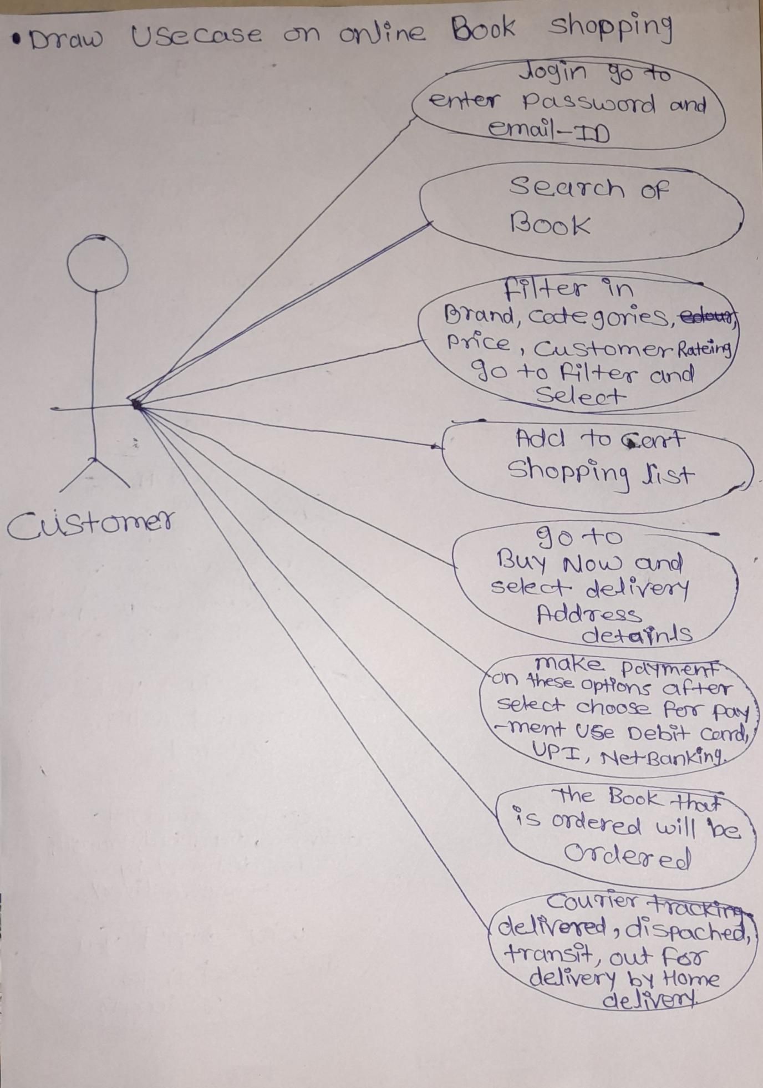

* Draw Use-case on online bill payment system (Paytm)

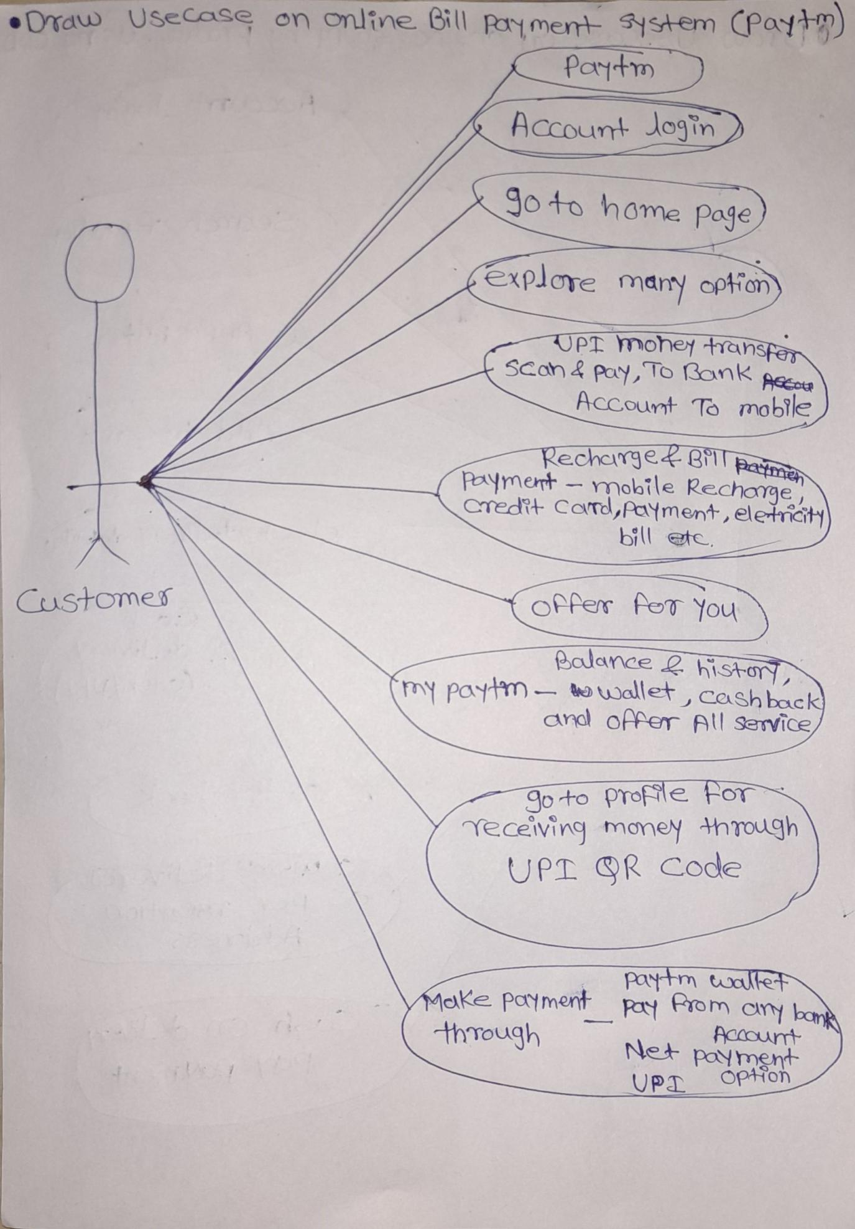

* Draw use case on online shopping product using COD

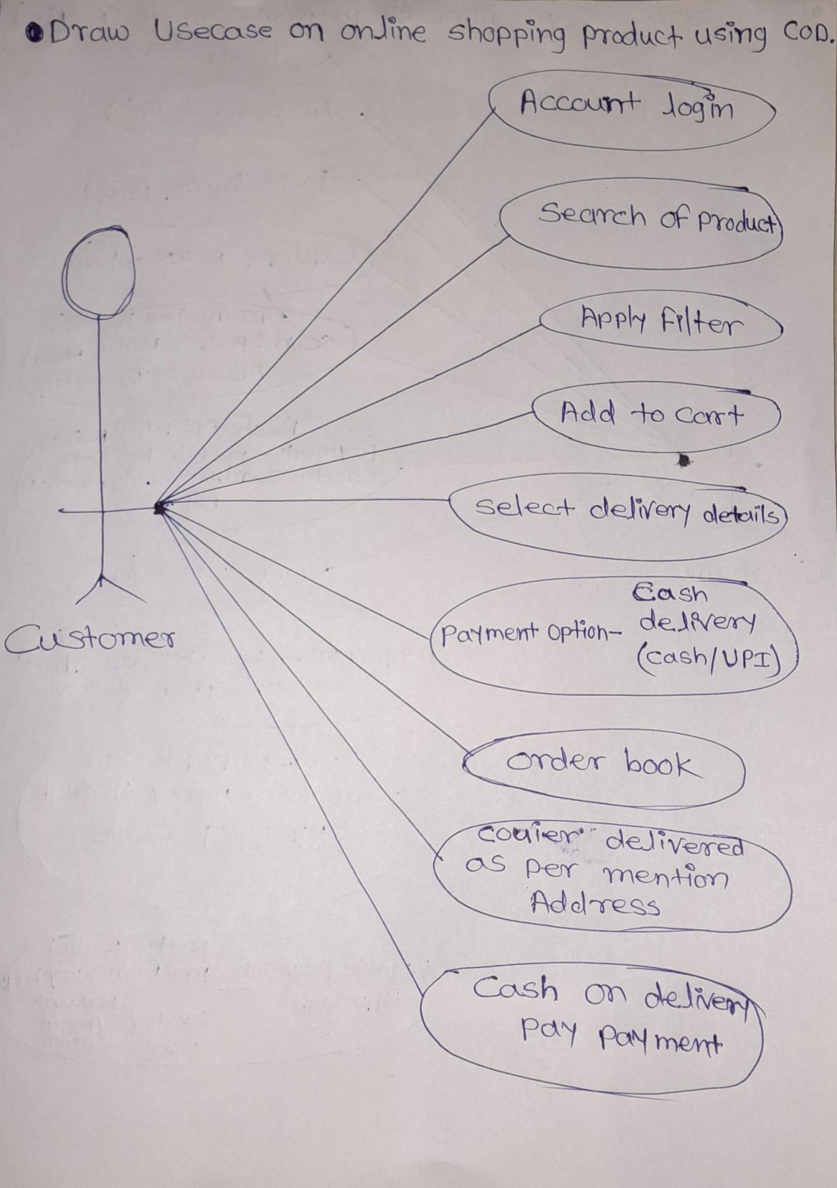

* Draw usecase on online shopping product using payment gateway

